Intro to Web Dev Final Report
Touchstone 3: Develop a Functional Website

Name: Draven Chen
Date: June 13, 2026
Final Program Share Link from the IDE:
https://stackblitz.com/edit/stackblitz-starters-xaxgim4e

Introduction

Client Name
Book Haven Bookstore
This report summarizes the design, structure, and functionalities of the website created for Book Haven Bookstore. The website serves as a digital storefront and community hub for this local independent bookstore, designed to showcase its diverse product offerings, facilitate customer engagement, and strengthen community connections. The design choices reflect the client's literary identity and commitment to fostering a love for reading among customers of all ages.
The website was built to address three primary client goals: (1) Product Promotion - showcasing the bookstore's range of books, magazines, stationery, and merchandise through an appealing gallery; (2) Engagement - attracting potential customers and encouraging them to visit in person or contact the store; and (3) Contact - making it easy for customers to inquire about products and place custom orders.

Color Palette and Logo Choice
Color Palette 1 was selected as the color palette for the website. The chosen color palette thoughtfully reflects the essence of the Book Haven Bookstore brand:
- Inkwell Blue (#1B3A4B): This deep, sophisticated blue serves as the primary color for headers and key structural elements. It evokes the classic image of leather-bound books and quiet reading nooks, establishing a refined literary atmosphere.
- Aged Gold (#C9A227): Used as an accent color for borders, hover effects, and highlights. This warm gold suggests aged book pages and antique gold leaf lettering, adding warmth and a sense of timelessness.
- Parchment White (#F5F1E8): The background color creates a soft, inviting canvas reminiscent of aged paper, providing a comfortable reading experience.
- Dusty Rose (#C9A8A0): A muted pink used sparingly for testimonial backgrounds and secondary accents, adding subtle warmth without overwhelming the design.
- Intensity Indigo (#3D5A80): A medium blue used for navigation buttons, links, and interactive elements, providing visual hierarchy and clear call-to-action points.
Logo 1 with Inkwell Blue (#1B3A4B) was selected as the logo color. The circular logo design with the bookstore name works well with the warm parchment background and provides a sophisticated, recognizable brand mark for the client.

Font Color Choice
Font Color 2, labeled Bookish Black (#131C26), was selected as the primary font color for the website. This near-black color with subtle blue undertones provides excellent readability against the Parchment White background while harmonizing with the overall cool blue palette. The color is softer than pure black, reducing eye strain during extended reading and complementing the literary theme of the bookstore.

Typography Choice
Typography Option 2 was selected as the typography for the website. The chosen typography creates a careful balance between readability and visual appeal:
- Arial: Used as the primary body font for its clean, modern readability across all screen sizes. Its neutral sans-serif design ensures content remains accessible and easy to read.
- Calibri: Used as a secondary font for supporting text elements, providing subtle visual variety while maintaining consistency.
- Comfortaa: Used for all headings (h1-h6) through Google Fonts. This rounded, friendly display font adds warmth and personality to section titles while maintaining excellent legibility. Its distinctive character complements the bookstore's welcoming atmosphere.
The typography choices collectively contribute to a visually cohesive and user-friendly design that resonates with the bookstore's brand identity as a welcoming community space for readers.

Wireframes
Wireframes for both desktop and mobile platforms were created during the planning phase to establish the layout structure for all four webpages. These wireframes served as blueprints for the HTML structure and CSS styling.

Desktop Wireframes
The desktop wireframes were designed for a standard viewport width of 1200px and above. Each page follows a consistent structure with a header containing the logo, title, and navigation bar, followed by a main content area organized into distinct sections, and concluding with a footer containing newsletter subscription, social media links, and secondary navigation.
The Homepage desktop wireframe includes five sections arranged vertically: a welcome overview, three promotional offer boxes arranged side by side, featured product images displayed horizontally, three shopping perk boxes, and a two-column product categories list.
The Gallery page desktop wireframe displays a cart summary bar at the top, followed by a 3x3 product table with each cell containing an image, product name, description, price, and Add to Cart button.
The About Us page desktop wireframe includes the about description, a business hours table, a contact form with all input fields, and a saved submissions display section.
The Events page desktop wireframe features customer testimonial boxes, community involvement cards, an events table, and a partners list.

Mobile Wireframes
The mobile wireframes were designed for viewports 768px and below. The layout adapts through responsive design principles: the navigation bar stacks vertically, multi-column layouts become single-column, tables become horizontally scrollable, and the cart modal takes up nearly the full screen for ease of use on touch devices.
[Note: Wireframe screenshots should be inserted here from the design phase files.]

Website Structure and Content
The website consists of four unique webpages, each designed to serve specific business functions while maintaining visual and structural consistency. Every webpage includes a header section and a footer section to provide unified navigation and branding throughout the site.
The header section contains the client logo on the left (which functions as a clickable link redirecting to the Homepage), the webpage title in the center, and a horizontal navigation bar on the right with links to all four pages.
The footer section contains a subscribe-to-newsletter feature with email input and Subscribe button, social media links (Facebook, Instagram, Twitter), a secondary horizontal navigation bar, and copyright information.

1) Home Page: index.html
The Home page serves as the digital storefront's main entrance and contains five distinct sections:
- Welcome Section: Provides a general overview of Book Haven Bookstore, describing its mission to foster literary exploration and its diverse product offerings including books, magazines, journals, and office supplies.
- Promotions Section: Displays three promotional offer boxes side by side - Summer Reading Sale (20% off fiction), Buy 2 Get 1 Free magazine offer, and Student Discount (15% off journals and notebooks).
- Featured Products Section: Showcases three featured product images with descriptive alt text for accessibility - Brie Mine 4Ever, Glory Riders, and Sorcerer's Shadowed Chronicles book covers.
- Shopping Perks Section: Highlights three customer benefits - Free Local Delivery on orders over $25, Loyalty Rewards program, and Complimentary Gift Wrapping.
- Product Categories Section: Displays a two-column grid listing all six product categories: Fiction & Literature, Non-Fiction & Biographies, Children's Books, Magazines & Journals, Office Supplies & Stationery, and Bookstore Merchandise.

2) Gallery Page: gallery.html
The Gallery page is the primary product showcase and shopping interface. It contains:
- A cart summary bar displaying the current item count and a View Cart button.
- A 3x3 table displaying nine products with images, names, descriptions, prices, and Add to Cart buttons. Products include three books (Brie Mine 4Ever at $14.99, Glory Riders at $16.99, Sorcerer's Shadowed Chronicles at $18.99), three magazines (Ball Magazine at $7.99, Travel Magazine at $8.99, Eat. Magazine at $9.99), and three merchandise items (Canvas Tote Bag at $24.99, Book Haven Notebook at $12.99, Reading Stickers at $5.99).
- Cart action buttons (Clear Cart and Process Order) below the product table.
- A modal dialog that displays cart contents when View Cart is clicked, showing item details, individual Remove buttons, total price, and Clear Cart/Process Order actions.

3) About Us / Contact Page: about.html
The About Us page provides business information and customer communication tools:
- About Section: Describes Book Haven Bookstore's history, mission, commitment to fostering literary exploration, and target audience of avid readers, students, and knowledge seekers.
- Hours of Operation Table: A bordered table displaying business hours (Monday-Friday 9 AM-8 PM, Saturday 10 AM-6 PM, Sunday 11 AM-5 PM).
- Contact Form: A comprehensive form with fields for Full Name (required), Email Address (required), Address, Phone Number, Subject dropdown (General Feedback, Custom Order Request, Question), a Custom Order checkbox, and a Message textarea. Includes Submit and Clear Form buttons.
- Saved Submissions Section: Dynamically displays all previously submitted form entries stored in localStorage, with individual delete buttons and a Clear All Saved Submissions option.

4) Custom Page - Events & Community: events.html
The Events & Community page is the custom fourth page designed to showcase the bookstore's community engagement:
- Customer Spotlight Section: Four testimonial boxes featuring customer quotes from Sarah M., James T., Emily R., and David K., each highlighting different aspects of the bookstore experience.
- Community Involvement Section: Four informational boxes describing Local School Partnerships, Community Literacy Program, Book Donation Drives, and Local Author Showcase initiatives.
- Upcoming Events Table: A detailed table listing five upcoming events with dates, times, and descriptions (Mystery Book Club, Children's Story Time, Local Author Reading, Summer Reading Kickoff, Writing Workshop Series).
- Partners List: An organized list of five community partners including Oakwood Public Library, Riverside Community Center, Local Writers Guild, Oakwood Elementary School, and Coffee Corner Cafe.

Website Design and Styling

Overall Design
The website design and styling follow the literary theme and warm, welcoming character of Book Haven Bookstore. The colors selected for different sections and components conform to the selected color palette, and the fonts applied follow the typography choice.

Header Design
The header section uses Inkwell Blue (#1B3A4B) as the background with a 5px solid Aged Gold (#C9A227) bottom border. The logo is centered and styled with a circular border and gold outline. The page title uses Comfortaa font in Parchment White (#F5F1E8) color with a subtle text shadow for depth. Navigation links are styled as rounded pill buttons with Intensity Indigo (#3D5A80) background, changing to Aged Gold on hover with a slight upward transform animation.

Footer Design
The footer mirrors the header's Inkwell Blue background with a gold top border. The newsletter section includes an email input field with gold border and rounded corners, and a Subscribe button with gold background that changes to parchment on hover. Social media links appear in gold and change to white on hover. The secondary navigation uses outlined pill buttons that fill with gold on hover.

Homepage Styling
The promo boxes use Inkwell Blue background with gold headings and parchment text, arranged in a flex container with hover lift effects. The shopping perk boxes use Aged Gold background with Inkwell Blue text for visual contrast. Featured product images have gold borders with subtle scale transforms on hover. Product categories are displayed as styled pill badges in a two-column grid.

Gallery Page Styling
Product cells use white backgrounds with gold borders and rounded corners, featuring hover lift effects. Product prices are displayed in Aged Gold with bold Comfortaa font. The cart summary bar uses Inkwell Blue background with prominent gold View Cart button. The modal window features a fade-in animation with white content area, gold border, and slide-in effect.

About Us Page Styling
The business hours table uses Inkwell Blue header row with parchment text, alternating row backgrounds, and gold borders. The contact form features a fieldset with Inkwell Blue border, gold-bordered input fields that change to blue on focus, and styled Submit/Clear Form buttons. Saved order cards use white backgrounds with gold borders and subtle shadow effects.

Events Page Styling
Testimonial boxes use Dusty Rose background with a left blue border accent. Community involvement boxes use Inkwell Blue background with gold headings. The events table features a blue header with left-aligned text, alternating parchment and white rows, and hover effects that change row backgrounds to Dusty Rose. Partner list items feature gold left borders that change to blue on hover with a slight rightward shift.

Accessibility
To provide an accessible experience to all users, the following accessibility best practices were implemented throughout the website:
- Color Contrast Compliance: All text and background color combinations were tested using the Adobe Color Accessibility tool (color.adobe.com/create/color-accessibility) to ensure they meet WCAG AA standards for contrast ratios. The Bookish Black (#131C26) font color on Parchment White (#F5F1E8) background provides a contrast ratio exceeding 12:1, well above the required 4.5:1 for normal text. Navigation buttons use Parchment White text on Intensity Indigo background for a ratio of 4.7:1, meeting AA standards.
- Semantic HTML Structure: The website uses proper semantic HTML5 elements including header, nav, main, section, footer, table with th headers, and form with fieldset/legend. This ensures screen readers can correctly interpret page structure and navigate between sections. All tables include proper header rows with th elements and meaningful column headers.
- Alternative Text for Images: Every image on the website includes descriptive alt text that conveys the content and purpose of the image. For example, product images include the full product name (e.g., 'Brie Mine 4Ever book'), and the logo includes 'Book Haven Bookstore Logo' as alt text. This ensures visually impaired users understand visual content through screen readers.
- Keyboard Navigation Support: All interactive elements including navigation links, buttons, form inputs, and the cart modal are fully accessible via keyboard. Visible focus styles using a 3px gold outline with 2px offset ensure keyboard users can track their position on the page. The:focus pseudo-class is applied consistently to all interactive elements.
- ARIA Labels and Form Accessibility: Form inputs use proper label elements associated with input fields via the for attribute. Required fields are marked with the required attribute, providing native browser validation. The contact form uses a fieldset with legend for grouping related controls, and select elements include meaningful option text.
- Skip Navigation and Reduced Motion: A skip-to-main-content link is available for screen reader users to bypass repetitive navigation. The website respects the prefers-reduced-motion media query, removing animations for users who prefer reduced motion. Additionally, high contrast mode is supported via prefers-contrast: high media query.

Responsive Web Design
The website implements responsive design principles to ensure optimal viewing across various devices and screen sizes. The following RWD elements were incorporated:
- Viewport Meta Tag: Each HTML page includes the viewport meta tag in the head section: <meta name="viewport" content="width=device-width, initial-scale=1.0"/>. This ensures the browser renders the page at the device's width with an initial zoom level of 1.0, which is essential for proper responsive rendering on mobile devices.
- Flexible Grid Layouts: The CSS uses flexbox containers with flex-wrap: wrap for multi-column layouts (promo boxes, perk boxes, testimonials, community boxes). This allows content to reflow naturally as viewport width decreases. The product categories use CSS Grid with repeat(2, 1fr) on desktop, switching to a single column on mobile via media queries.
- Responsive Media Queries: Two primary breakpoints are implemented - 768px for tablets and 480px for mobile phones. At 768px and below, navigation links stack vertically, multi-column layouts become single-column, tables become horizontally scrollable, and the cart modal expands to 95% width. At 480px and below, font sizes scale down and padding reduces further for optimal small-screen viewing.
- Fluid Images and Typography: All images use max-width: 100% and height: auto to scale proportionally within their containers. Font sizes use relative units (em) for headings, allowing text to scale with user preferences. The base font size adjusts from 16px on desktop to 14px on small mobile devices.
- Touch-Friendly Interactive Elements: All buttons and navigation links have adequate padding (minimum 12px vertical) and are spaced appropriately for touch interaction. The navigation links on mobile expand to 90% width with centered text, making them easy to tap. Form inputs use larger touch targets on mobile with full-width layouts.

Website Functionality
The website is designed to be dynamic and interactive, incorporating JavaScript functionality to enhance user engagement. The following features are implemented across all four webpages:

Navigation Bar
Both the header and footer contain interactive navigation bars that allow users to move between all four pages of the website. The navigation links in the header are styled as rounded pill buttons with hover effects that change the background color from Intensity Indigo to Aged Gold and shift the button slightly upward. The footer navigation uses outlined buttons that fill with gold on hover. Clicking any navigation link loads the corresponding HTML page. The bookstore logo in the header also functions as a clickable link that redirects to the Homepage.

Subscribe Feature
The footer section of each page includes a newsletter subscription feature. An email input field with placeholder text prompts users to enter their email address. When the user enters a valid email and clicks the Subscribe button, a JavaScript event listener intercepts the form submission using preventDefault(), then displays an alert window with the message 'Thank you for subscribing.' The email input uses the HTML5 'email' type which provides native browser validation, ensuring users enter a properly formatted email address before submission.

Add to Cart Feature
The Gallery page implements an Add to Cart feature for all nine products. Each product cell contains an 'Add to Cart' button with data attributes (data-id, data-name, data-price) storing product information. When clicked, a JavaScript event listener reads these attributes, creates an item object, retrieves the existing cart from sessionStorage using getCart(), adds the new item to the array, saves the updated cart back to sessionStorage using saveCart(), updates the cart count display, and shows a confirmation alert with the item name and price. Helper functions encapsulate the JSON parsing and stringifying operations required for sessionStorage.

View Cart Feature
The View Cart feature opens a modal dialog that displays all items currently in the shopping cart. When the View Cart button is clicked, the displayCartItems() function reads cart data from sessionStorage, dynamically generates HTML for each item showing the name, price, and an individual Remove button, calculates the total price by summing all item prices, and displays the modal with a fade-in animation. The modal includes a close button (X) in the top right corner and can also be closed by clicking outside the modal window. If the cart is empty, a message 'Your cart is empty.' is displayed.

Clear Cart and Process Order Features
Both the main Gallery page and the cart modal include Clear Cart and Process Order buttons. The Clear Cart function removes all cart data from sessionStorage, updates the cart count to zero, refreshes the modal display, and shows an alert confirming 'Cart cleared.' The Process Order function checks if the cart contains items; if empty, it alerts the user to add items first. If items exist, it calculates the total, clears sessionStorage, updates the display, and shows a confirmation alert with the message 'Thank you for your order! Total amount: $XX.XX'. Individual items can also be removed using the Remove button next to each cart item.

Contact Us Feature
The About Us page includes a comprehensive Contact Us form with JavaScript functionality. When the user fills out the form and clicks Submit, an event listener intercepts the submission, collects values from all input fields (name, email, address, phone, subject, custom order checkbox, message), creates a data object with a timestamp, saves it to localStorage, refreshes the saved submissions display, shows a context-aware confirmation alert (custom order vs. general feedback), and resets the form. The Clear Form button resets all form fields to their default values. The form uses HTML5 validation attributes (required on name and email) to ensure essential data is provided.

Web Data Storage
The website utilizes the Web Storage API, incorporating both sessionStorage and localStorage to provide persistent data management. Each storage mechanism was selected based on the specific requirements of the feature it supports.

Shopping Cart Feature - sessionStorage
The Shopping Cart feature uses sessionStorage with the key 'bookHavenCart'. sessionStorage was chosen because cart data should persist during the browsing session but be automatically cleared when the browser tab is closed, which is the expected behavior for a shopping cart that does not need to persist across multiple visits.
The implementation follows this workflow: Each time an 'Add to Cart' button is clicked, the item object {id, name, price} is added to the cart array stored in sessionStorage. The 'View Cart' feature reads all entries from sessionStorage and displays them in the modal window with individual Remove buttons. The 'Clear Cart' feature calls sessionStorage.removeItem('bookHavenCart') to remove all cart data. The 'Process Order' feature also removes entries from sessionStorage after confirming the order. Because sessionStorage is scoped to a single tab, cart data remains isolated and secure across browser sessions.
Helper functions getCart() and saveCart() encapsulate the JSON operations: getCart() retrieves and parses the stored JSON string, defaulting to an empty array if no cart exists; saveCart() stringifies the cart array and stores it. This modular approach ensures consistent data handling and simplifies debugging.

Contact Us Feature - localStorage
The Contact Us / Custom Order feature uses localStorage with the key 'bookHavenOrders'. localStorage was chosen because customer submissions and custom order requests should persist across browser sessions, allowing users to reference their previous submissions when they return to the site.
When the Submit button is clicked, the following sequence occurs: The form submission event is intercepted using preventDefault(). Form values are collected from all input fields. An order data object is created containing name, email, address, phone, subject, custom order status, message, and a timestamp. Existing orders are retrieved from localStorage, the new order is added to the array, and the updated array is saved back. The saved orders display section is then refreshed to show the new submission.
The Saved Orders section on the About Us page displays all stored orders in reverse chronological order (most recent first). Each order appears as a styled card with all submitted information and an individual Delete button. A 'Clear All Saved Submissions' button with a confirmation dialog allows users to remove all stored data. If no orders exist, an appropriate empty-state message is displayed. This persistence ensures users can reference their custom order history across multiple visits to the website.

Customization
The Events & Community page serves as the custom fourth page, adding significant value to the Book Haven Bookstore website by extending beyond the basic commercial functionality of the Homepage, Gallery, and About Us pages. This page establishes the bookstore not merely as a retail establishment but as a vibrant community hub and cultural center.
While the Homepage introduces the bookstore and its offerings, the Gallery page showcases products for purchase, and the About Us page facilitates communication, the Events & Community page creates deeper community engagement. It highlights authentic customer experiences through testimonials, demonstrates the bookstore's commitment to social responsibility through community involvement descriptions, provides practical information about upcoming events that encourage in-person visits, and showcases partnerships with local organizations.
This page directly supports the client's engagement goal by giving potential customers multiple reasons to visit beyond purchasing - attending book clubs, participating in writing workshops, bringing children to story time, or meeting local authors. The community involvement section reinforces the bookstore's values and trustworthiness, while the events table creates urgency and provides clear calls to action with specific dates and times. The partners list further embeds the bookstore within the local community ecosystem, suggesting a stable, connected business that customers can feel good about supporting.
From a design perspective, the Events page maintains visual consistency with the rest of the site while introducing unique layout elements - the testimonial cards with their distinctive left border accents, the community boxes with inverted color schemes, and the comprehensive events table - that keep the user experience fresh and engaging across all pages.

Screenshots of Rendered Webpages

Homepage
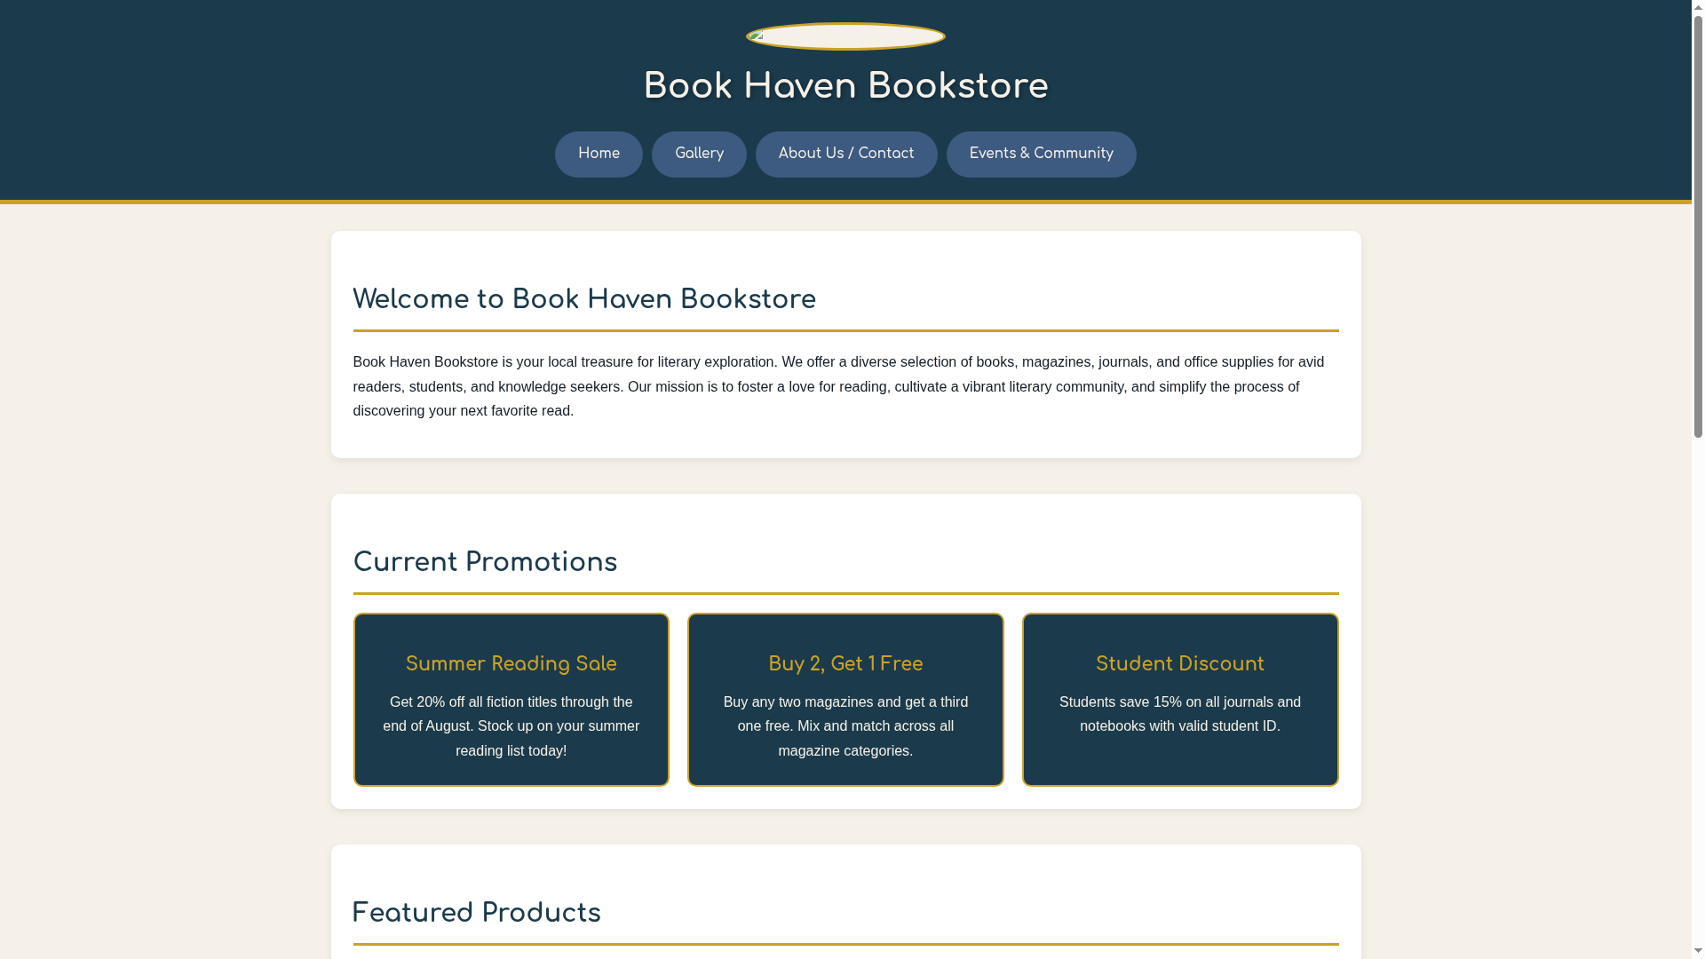
Homepage: Shows the header with logo and navigation, welcome section, three promotional offer boxes, featured product images, shopping perks, and product categories, followed by the footer with newsletter subscription.

Subscribe Feature

Subscribe feature: Shows the email input field with placeholder text and the Subscribe button in the footer section.
The Subscribe feature uses HTML5 email input validation. When an invalid email format is entered, the browser displays a native validation tooltip prompting the user to match the requested format.

Gallery Page
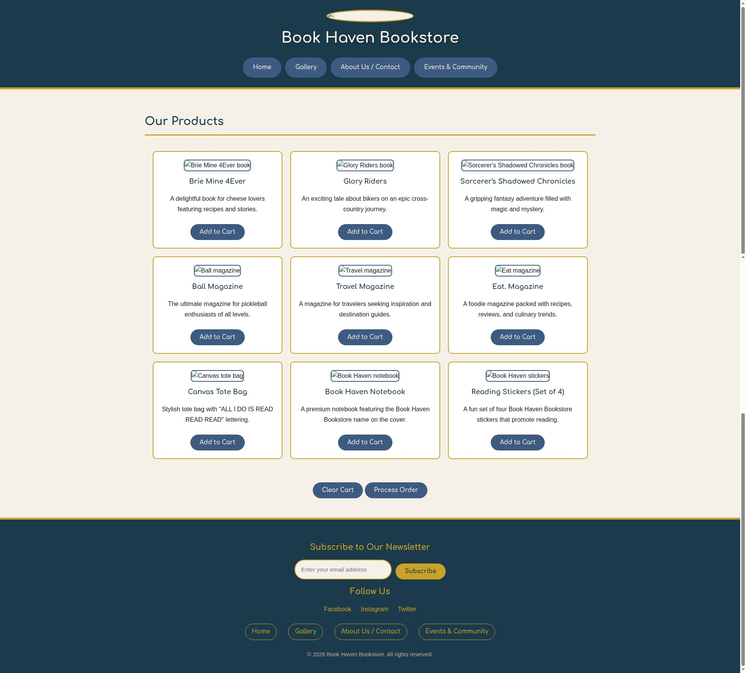
Gallery page: Displays the cart summary bar with item count, the 3x3 product table with all nine products, and cart action buttons.
When the Add to Cart button is clicked, a JavaScript alert displays a confirmation message with the item name and price. The cart count in the summary bar updates immediately to reflect the added item.
Clicking the View Cart button opens a modal dialog displaying all items currently in the cart, including item names, individual prices, and the calculated total. Each item has a Remove button, and the modal provides Clear Cart and Process Order actions.
The Process Order button checks if the cart contains items. If items exist, it calculates the total price, clears the cart from sessionStorage, and displays a confirmation alert with the message: "Thank you for your order! Total amount: $XX.XX."
The Clear Cart button removes all items from sessionStorage, updates the cart count display to zero, and shows an alert confirming: "Cart cleared." Individual items can also be removed using the Remove button next to each cart item in the modal.
Cart data is stored in sessionStorage under the key 'bookHavenCart'. The browser's Developer Tools Application tab displays the stored JSON array containing item objects with id, name, and price properties. This data persists during the browsing session and is automatically cleared when the tab is closed.

About Us Page
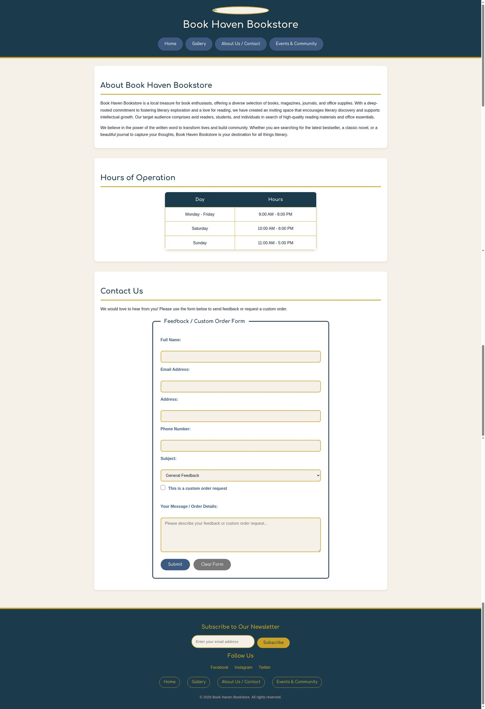
About Us page: Shows the About section, Hours of Operation table, Contact form, and Saved Submissions section.
The Contact Us form includes fields for Full Name (required), Email Address (required), Address, Phone Number, Subject dropdown, Custom Order checkbox, and a Message textarea. HTML5 validation ensures required fields are completed before submission.
Submitted form data is stored in localStorage under the key 'bookHavenOrders'. The Developer Tools Application tab shows the persisted JSON array of order objects, each containing name, email, address, phone, subject, custom order status, message, and a timestamp. This data persists across browser sessions.
The contact form uses HTML5 validation attributes. If required fields (Full Name, Email Address) are left empty or contain invalid data, the browser displays a native validation message and prevents form submission until the errors are corrected.

Custom Page - Events & Community
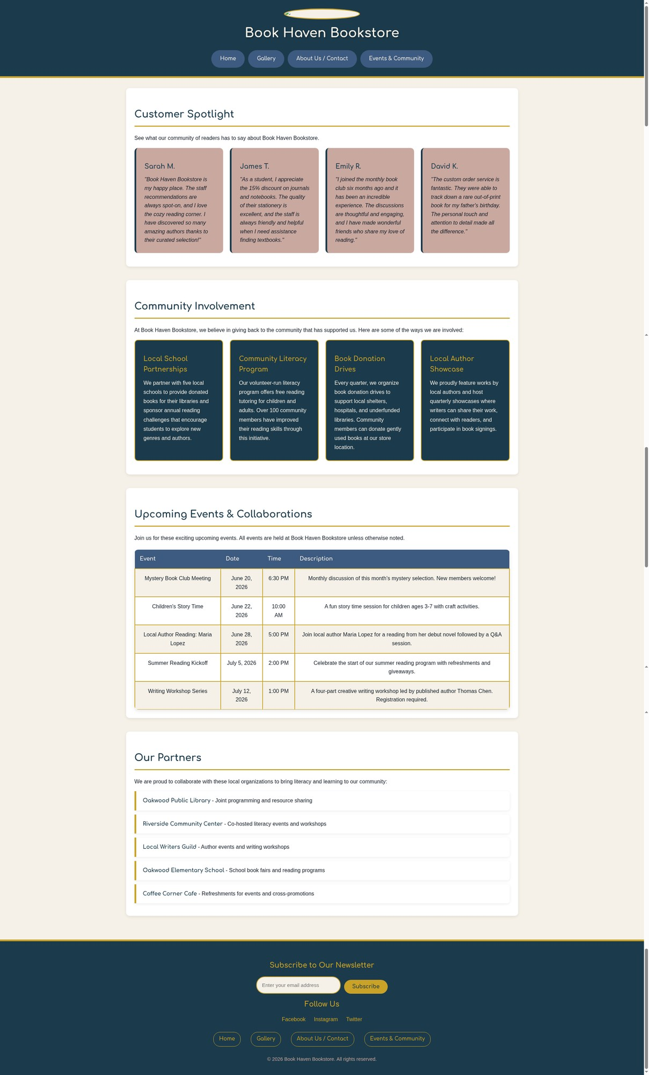
Events & Community page: Shows the Customer Spotlight testimonials, Community Involvement boxes, Upcoming Events table, and Partners list.

Description of Issues
During the development of this website, the following design considerations and adjustments were addressed:
One consideration involved ensuring consistent styling across all four pages while maintaining unique visual identities for each page type. The solution was to use shared CSS classes for common elements (buttons, navigation, headers/footers) while creating page-specific classes for unique components. This modular approach kept the stylesheet organized and made updates straightforward.
Another consideration was the choice between sessionStorage and localStorage for each feature. sessionStorage was determined to be appropriate for the shopping cart because cart contents are temporary and should not persist across browsing sessions - this matches user expectations for an e-commerce experience. localStorage was chosen for the custom order form because users may want to reference their submission history when they return to the site, making persistence across sessions valuable.
The modal window for the shopping cart required careful z-index management and event handling to ensure it displayed correctly above all other content and could be closed via multiple methods (close button, clicking outside, or completing an action). The implementation used a z-index of 1000 for the modal overlay and event delegation for dynamically generated Remove buttons.
No critical errors were encountered during development or testing. All components function as intended. The implementation followed a consistent pattern throughout: wrapping storage operations in helper functions, using JSON.parse() and JSON.stringify() for complex data objects, and separating data access functions from UI update functions. This modular architecture made the code easier to test, debug, and extend.

